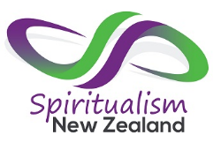
Weekend of Spiritual Workshops
Rotorua Church of Spiritual Healing
Linton Park Community Centre
16 Kamahi Place
Rotorua
15 minute private readings for $20 will be available throughout Saturday and Sunday.
Workshops $20 for Spiritualism New Zealand members or regular attendees at local spiritual Churches and Centres that are members of Spiritualism New Zealand or $25 for each workshop
Bookings can be made online on the Events Calendar at www.spiritualism.org.nz, or during the weekend

Saturday 19 September

9.00 – 10.30am
Clairvoyant Morning – Kick off the weekend with uplifting messages from spirit from 3 experiecned mediums. Also hear information about the workshops that will be happening during the weekend and book your space for those one’s that you are interested in attending or for a private 15 minute reading. Cost $10 on entry

11.00 – 1.00pm
Psychometry with Anne - This is the ability to sense the energies in a physical object like a piece of jewellery and be able to describe its owner, their associated emotions and even the object’s history. It’s similar to a psychic reading but we’re reading an object instead of a person. And the good thing about objects is that they don’t mind when we get it wrong! We’ll be discussing how it works, doing a short meditation and having a go at it ourselves. Bring along 2-3 small objects (e.g. piece of jewellery, small ornament) each in an envelope or wrapped, that you know the history of and that has only ever been owned by one person. (Hint, you can borrow them from family and friends.)

OR
Violet Flame with Barbara - The Violet Flame is one of the most powerful energies available to humanity today. Connect with St Germaine and through a series of meditations, learn how to use it to clear negative energies from yourself, your home, your environment, Mother Earth and our atmosphere.

2.00 – 4.00pm
Channelling with Sue- This workshop will give you an opportunity to start working with your guides and connections to channel information from spirit. We will do a connecting meditation and various exercises to help you start this process. Share our spiritual experiences about this fascinating topic.

OR

Living Spiritually with Barbara - What does it mean to live spiritually? How can you do this and what is the purpose? Gain an understanding of your spiritual side and how you can incorporate it into your daily life to allow yourself to move more smoothly through the ups and downs of human existence. Learn about how your own energies are affected by the energy of the world around you and what it means to raise your energy vibrations.

Sunday 20 September
9.00 – 11.00am
Guides Circle of Learning with Sue - This workshop is for all levels of development. There will be spiritual exercises to show you are already connected, and are able to work with Spirit. There will be:
- A short meditation to get started
- The Fountain of Gifts-a chance to try out the ‘clairs’
- The rose meditation exercise-giving readings to others.
- A trance session at the end with Sue’s guide. A chance to ask questions and clarify your journey.

OR
Introduction to Numerology with Anne - As physical objects, our atoms vibrate. Sounds are a vibration and therefore so are our names. When we hear our names on a daily basis, that recurring sound affects our vibration. Numerology assigns numbers to vibrations which in turn have influencing properties. Pythagoras worked out the numerical value of letters in the alphabet which can be used to calculate their associated vibration and influence. We are going to look at common numbers and vibrations in our lives and use numerology to see what they could be

11.30 – 1.00pm
Ghost Busting, Land Clearing and House Blessings with Sue - A stimulating talk about what goes on during house cleansings and other ‘ghost busting’ sessions. A unique insight into the stories around these phenomena. Sue has done over 100 clearings, and will share her methods, what the ‘other side’ does to assist, the reasons for and the love that sends them on.
Learn about.
- Why people ask for help
- What we do
- What Spirit does
- Stories

OR
The Clairs with Barbara - What are they and which ones do you use? We’ll explore the 4 most well-known of these - clairvoyance, clairaudience, clairsentience and claircognisance and will also check out the 4 lesser known ones of clairalience, clairgustance, clairolfaction and clairtangency. After some discussion we will have a play with determining which one’s you already use or which will be your dominant clair as you move forward.

2.00 – 4.00pm
Pendulum Dowsing with Anne - We are connected to all things and not as separate as we appear. A pendulum can help you access intuitive knowledge you didn't know you had and knowledge you have hidden at a subconscious level (like where you left your car keys!). Your opportunity to train your pendulum and get it talking to you. Some discussion but a largely practical session, with lots of different fun exercises. Please bring a pendulum if you already have one.

OR

Public Speaking/Church Addresses with the help of Spirit with Barbara - A practical workshop to help you to channel spirit and allow them to give information to others. In this workshop we will explore what constitutes a good address and how you can work with spirit to allow this to happen. This is an opportunity for you to experiment and learn different ways of working with your guides, allowing them to speak through you and bring through wisdom for others to hear. This workshop will be held in a private home, address given to those attending. Numbers will be limited.

Meet the Mediums who will be presenting this weekend:
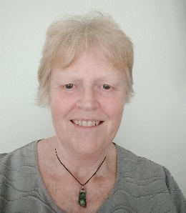
Anne Roughton – Anne’s spiritual journey became serious around 26 years ago when Spirit kept her awake knocking on the walls at night. They stopped bothering her when she joined a spiritual development class. She only ever intended to be a healer but Spirit had other ideas. She is a practising platform medium and Registered Spiritual Healer. She has led spiritual development classes but now leads only Spiritual Healing classes and spiritual workshops – and she is still learning herself. She is on both the Upper Hutt Spiritualist Centre and Spiritualism NZ committees. She is passionate about empowering people to help and heal themselves.

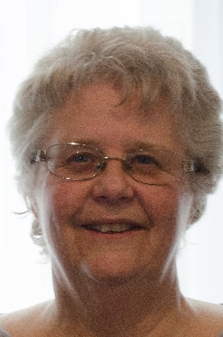
Barbara Hand – Barbara didn’t connect with spirit until she was in her 40’s but always knew there was something more to life than what she was experiencing. She joined the Petone Spiritualist Church and developed her skills by attending circles and workshops. She has been a part of the National Body for Spiritualism in New Zealand since 2005. For the past 25 years she has, as a practising medium, run church services, workshops, circles, spiritual retreats and spiritual fairs as well as helping people through private readings. She enjoys working with spirit in many different ways and has a huge trust in them, allowing her to channel them and include their teachings in her everyday life.
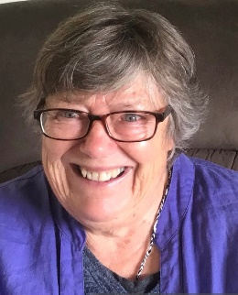
Sue Boyle - Sue has worked with Spirit for over 40 years as a channel for their wisdom words, healing and performing house cleansings and blessings. She moved to Upper Hutt and joined the spiritualist church, meeting like-minded people. She is now their Secretary, works on platform and as a reader and healer for the Oasis Healing Centre. The idea of bringing people together to support and empower them motivates her to be part of SNZ.

